COMSATS UNIVERSITY ISLAMABAD,

ATTOCK CAMPUS


Submitted by:- M. Haider Iqbal
Submitted to:- Ms. Ambreen Gul
Registration #:- SP24-BSE-039
Date:- 12-Oct-2025
Assignment No:- 02

Graded Task 01

AnsweR
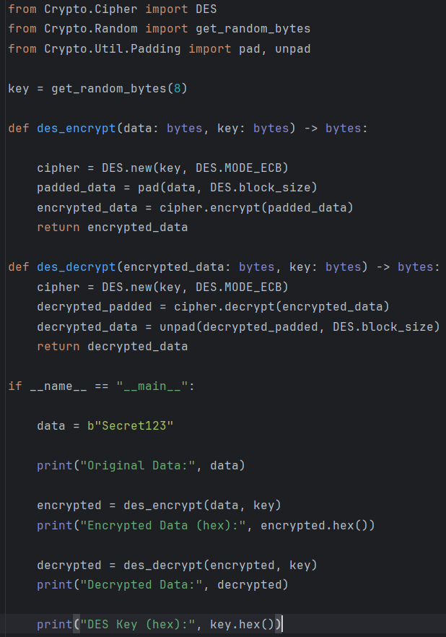

Output
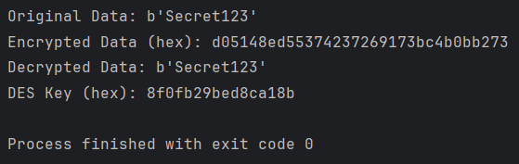

The code shows how to encrypt and decrypt data using DES (Data Encryption Standard) in ECB mode, and how to pad/unpad plaintext so it fits DES’s 8-byte block size. The same library functions are used in the lab manual example.

- from Crypto.Cipher import DES
— This imports the DES cipher class from the crypto library so we can create DES objects to encrypt and decrypt.
- from Crypto.Random import get_random_bytes
— This gives us a simple way to generate random bytes for the DES key.
- from Crypto.Util.Padding import pad, unpad
— DES works on 8-byte blocks. pad adds bytes so the plaintext length becomes a multiple of 8; unpad removes that added padding after decryption.
- key = get_random_bytes(8)
— DES requires an 8-byte key. This line creates 8 random bytes and saves them in key. In the example we print the hex of this key so you can see which key was used.

des_encrypt(data: bytes, key: bytes) -> bytes
Purpose: encrypt arbitrary-length plaintext with DES and return ciphertext.
Step-by-step:
- cipher = DES.new(key, DES.MODE_ECB)
— Create a DES cipher object in ECB mode using the provided 8-byte key. ECB is the mode shown in the manual.
- padded_data = pad(data, DES.block_size)
— Make the plaintext length a multiple of DES’s block size (8 bytes) by adding padding bytes (PKCS#7 style). This prevents errors if the plaintext isn't exactly 8, 16, 24... bytes.
- encrypted_data = cipher.encrypt(padded_data)
— Encrypt the padded data block-by-block. DES encrypts each 8-byte block and returns the concatenated ciphertext bytes.
- return encrypted_data
— Return the ciphertext bytes to the caller.
Simple takeaway: des_encrypt prepares the plaintext (pad) and then encrypts it using DES ECB with the given key.

des_decrypt(encrypted_data: bytes, key: bytes) -> bytes
Purpose: decrypt ciphertext back to the original plaintext bytes.
Step-by-step:
- cipher = DES.new(key, DES.MODE_ECB)
— Create a DES cipher object with the same key and same ECB mode (must match encryption).
- decrypted_padded = cipher.decrypt(encrypted_data)
— Decrypt the ciphertext to get the padded plaintext (still has padding bytes).
- decrypted_data = unpad(decrypted_padded, DES.block_size)
— Remove the padding bytes added during encryption to get the original plaintext length.
- return decrypted_data
— Return the original plaintext bytes.
Simple takeaway: des_decrypt reverses des_encrypt — decrypt then unpad.

if __name__ == "__main__": — Demo run
This part shows how to use the two functions. It’s what runs when you execute the file.
Step-by-step:
- data = b"Secret123"
— Choose a plaintext to encrypt. It must be bytes, so we prefix with b"...". In the example the plaintext is 9 bytes long.
- print("Original Data:", data)
— Print the plaintext so you can check it.
- encrypted = des_encrypt(data, key)
— Call the encryption function defined above. This returns ciphertext (bytes).
- print("Encrypted Data (hex):", encrypted.hex())
— Print the ciphertext in hexadecimal so it’s readable (binary bytes shown as hex string).
- decrypted = des_decrypt(encrypted, key)
— Decrypt the ciphertext to recover the original plaintext bytes.
- print("Decrypted Data:", decrypted)
— Print the decrypted result (should equal the original data).
- print("DES Key (hex):", key.hex())
— Print the random 8-byte key used (in hex) so you can reproduce or verify results.
Simple takeaway: This block shows encrypt → decrypt and prints everything so you can verify the round-trip works.

security notes
- DES uses 8-byte keys and is outdated for real security — it’s used here only because the manual teaches it. Real systems use AES or other modern ciphers.
- ECB mode (used here) is insecure for many uses because identical plaintext blocks produce identical ciphertext blocks. The manual uses ECB for teaching; in real systems choose CBC, GCM, or other secure modes and manage IVs correctly.
- Padding/unpadding is necessary because DES operates on fixed-size (8-byte) blocks.

This program demonstrates DES encryption and decryption in ECB mode: it pads the plaintext to fit 8-byte blocks, encrypts with a randomly generated 8-byte DES key, and then decrypts and unpads to recover the original message; the same key and mode must be used to correctly reverse the operation.
Graded Task 02

Answer
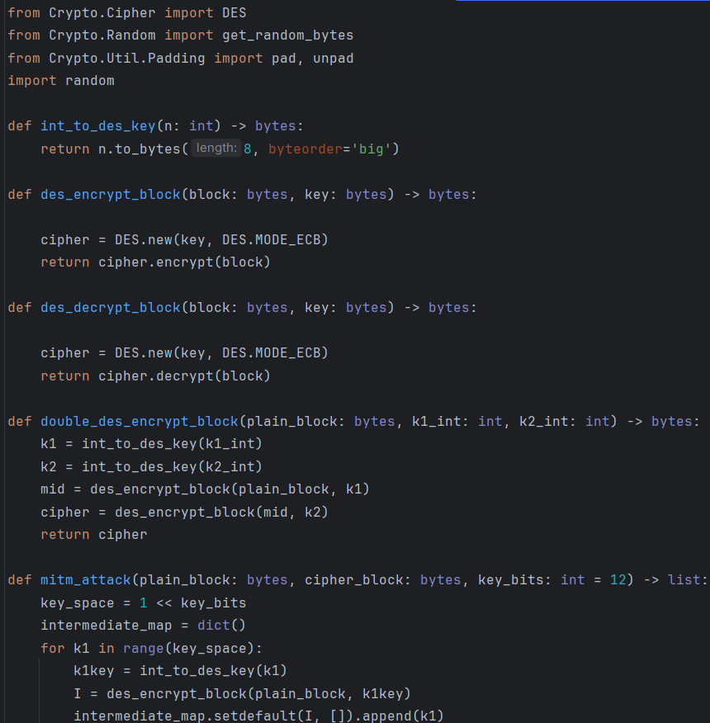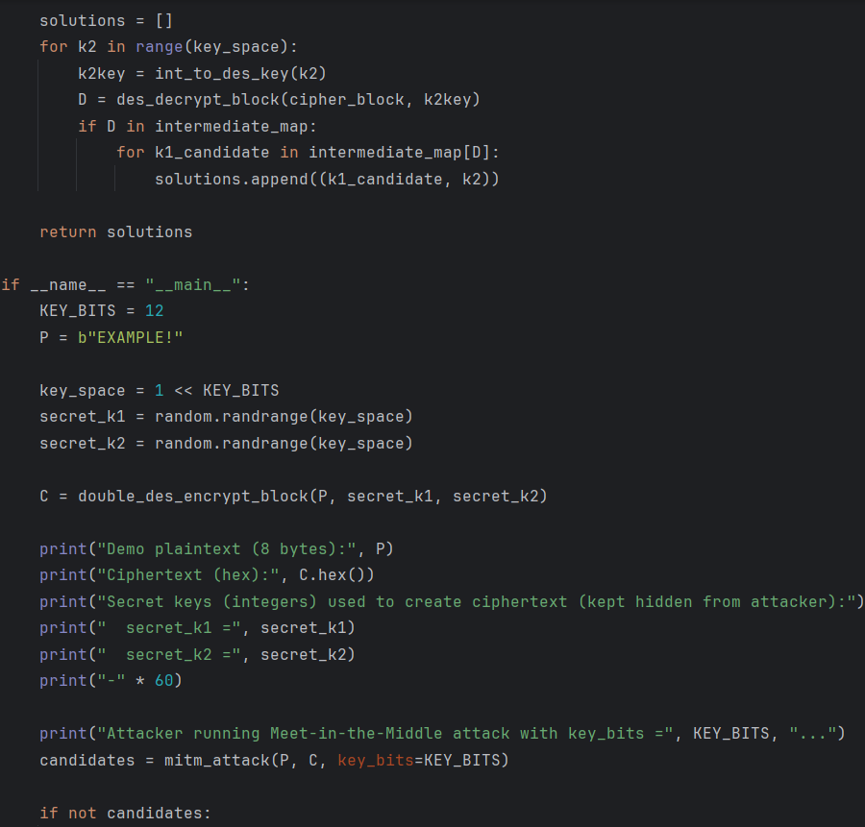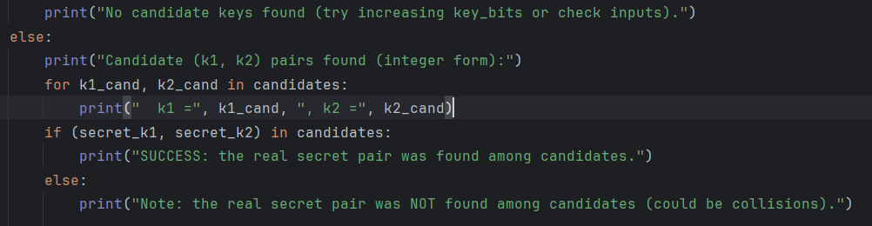

Output
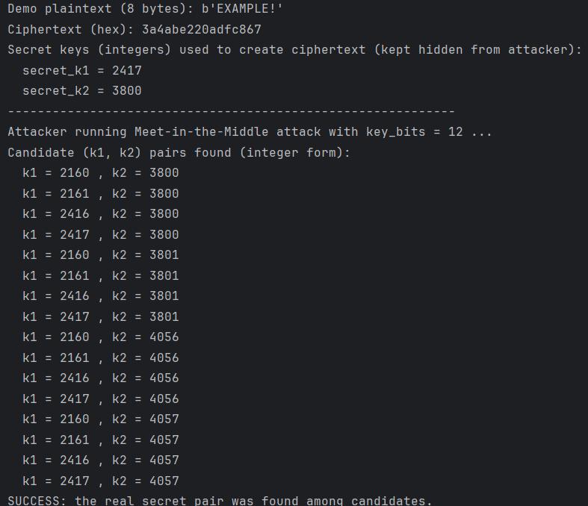

int_to_des_key(n: int) -> bytes
- Purpose: turn a small integer (like 5) into an 8-byte DES key (DES needs 8 bytes).
- What it does: n.to_bytes(8,'big') makes bytes like b'\x00\x00\x00\x00\x00\x00\x00\x05'.
- Why: this makes simple, unique keys for small integers so we can test many keys quickly in class.
des_encrypt_block(block, key) and des_decrypt_block(block, key)
- Purpose: encrypt or decrypt exactly one DES block (8 bytes) using ECB mode.
- What they do: create a DES cipher object from the key and call encrypt or decrypt.
- Important note: we do not pad here — the MITM explanation works on single 8-byte blocks.
double_des_encrypt_block(plain_block, k1_int, k2_int)
- Purpose: simulate the victim encrypting with double-DES (first K1 then K2).
- Steps:
  - Convert k1_int and k2_int into 8-byte keys (with int_to_des_key).
  - Encrypt plaintext with K1 to get an intermediate block.
  - Encrypt that intermediate block with K2 to get the final ciphertext.
- This simulates the real encryption the attacker observes (P and C).
mitm_attack(plain_block, cipher_block, key_bits=12)
This is the heart of the MITM method — exactly the flow shown in your lab manual.
- Purpose: find candidate key pairs (K1, K2) such that E_{K2}(E_{K1}(P)) == C.
- Key idea from the manual: split the search into two halves so you don't try all K1×K2 combinations.
- How it works (step-by-step):
  - Stage 1 (forward): For every possible k1 in [0, 2^key_bits):
    - Compute I = E_{k1}(P) (encrypt plaintext with k1).
    - Store I → k1 in a dictionary (a map from intermediate value to keys that produced it).
    - After this loop, we have a table of possible intermediate values for every k1.
  - Stage 2 (backward): For every possible k2 in [0, 2^key_bits):
    - Compute D = D_{k2}(C) (decrypt ciphertext with k2).
    - See if D exists in the Stage 1 table (i.e., if some k1 produced the same intermediate value).
    - If yes, then (k1, k2) is a candidate — their intermediate values match and therefore
E_{k2}( E_{k1}(P) ) == C for that pair.
- Why this is faster: Instead of testing 2^key_bits × 2^key_bits combos, we do 2 × 2^key_bits operations and a lookup (much faster in practice).
if __name__ == "__main__": (demo run)
- KEY_BITS = 12 — we pick a small key space so the code runs quickly on your computer (2^12 = 4096 possibilities per half). In real systems keys are much larger. The manual explains splitting the key into halves; here we pick a small half-size for demonstration.
- P = b"EXAMPLE!" — an 8-byte plaintext block (DES block size).
- We randomly pick secret_k1 and secret_k2 (these simulate the real keys the victim used).
- We compute the observed ciphertext C by double-encrypting P with secret_k1 then secret_k2.
- The attacker knows P and C and runs mitm_attack(P, C, key_bits=KEY_BITS) to find candidate key pairs.
- The program prints:
  - The ciphertext (so you can see it),
  - The candidate pairs found by the attack,
  - Whether the real secret pair appears among candidates.

- Meet-in-the-Middle splits the key search in two: encrypt the known plaintext with all possible K1 values, decrypt the ciphertext with all possible K2 values, and find matches — this recovers the key pair much faster than naive full search. (This is exactly what the lab manual explains.)

